# Final Required

# Code Description

**Video:** **finalRequiredCodeDescriptionProject.mp4**

Final Project Required Coding Activity

Introduction to Python Unit 1

**This Activity is intended to be completed in the jupyter notebook, Required_FINAL_Project_IntroPy.ipynb, and then pasted into the assessment page that follows.**

All course .ipynb Jupyter Notebooks are available from the project files download topic in Module 1, Section 1.

This activity is based on modules 1 - 4 and is similar to exercises in the Jupyter Notebooks **Practice_MOD04_1-6_IntroPy.ipynb**and **Practice_MOD04_1-7_IntroPy.ipynb** which you may have completed as practice.

| **Some Assignment Requirements** |
| --- |
| This program requires the use of **while** loop, **if, elif, else**, **if, else** (nested), **casting** of type, between strings and numbers. The program should **only** use code syntax covered in modules 1 - 4. The program must result in print output using the numeric input, similar to that shown in the samples displaying "Items" and "Total". |

Program: adding_report() function

This program calls the adding_report() function which repeatedly takes positive integer input until the user quits and then sums the integers and prints a "report".  
The **adding_report()** function has 1 string parameter which indicates the type of report:

* "A" used as the argument to adding_report() results in printing of all of the input integers and the total
* "T" used as the argument results in printing only the total

**Sample input and output:**

call adding_report() with "A" as argument (print all the integers entered and the total)

Input an integer to add to the total or "Q" to quit

Enter an integer or "Q": 3

Enter an integer or "Q": 6

Enter an integer or "Q": 24

Enter an integer or "Q": 17

Enter an integer or "Q": 61

Enter an integer or "Q": nine

nine is invalid input

Enter an integer or "Q": q

Items

3

6

24

17

61

Total

111

call with "T"(print only the total)

Input an integer to add to the total or "Q" to quit

Enter an integer or "Q": 5

Enter an integer or "Q": 7

Enter an integer or "Q": Quit

Total

12

**The forever (while True) loop diagram**

This diagram represents only part of the assignment - it is the loop and nested if statements inside the function. The code will enter at the while True loop after initializing variables.

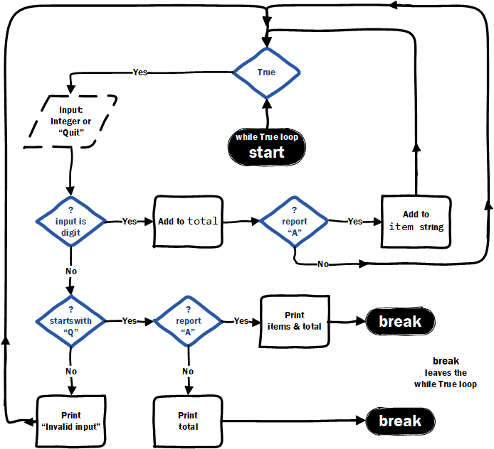

**Additional Details**

* initialize total variable which will sum integer values entered
* initialize items variable which will build a string of the integer inputs separated with a *new line character*
* define the adding_report function with one parameter report that will be a string with default of "T"
* inside the function build a forever loop (infinite while loop) and inside the loop complete the following
  + use a variable to gather input (integer or "Q")
  + check if the input string is a digit (integer) and if it is...
    - add input iteger to total
    - if report type is "A" add the numeric character(s) to the item string seperated by a new line
  + if not a digit, check if the input string is "Q" or starts with a "Q", **if "Q"** then...
    - if the report type is "A" print out all the integer items entered and the sum total
    - if report type is "T" then print out the sum total only
    - break out of while loop to end the function after printing the report ("A" or "T")
  + if not a digit and if not a "Q" then print a message that the "input is invalid"
* Call the adding_report function with "A" and then with "T" report parameters
* Run and test your code before submitting

# [ ] create, call and test the adding_report() function

# then PASTE THIS CODE into edX

Important: [How to submit code by pasting](https://courses.edx.org/courses/course-v1:Microsoft+DEV236x+1T2017/wiki/Microsoft.DEV236x.1T2017/paste-code-end-module-coding-assignments/)